An Garda Síochána

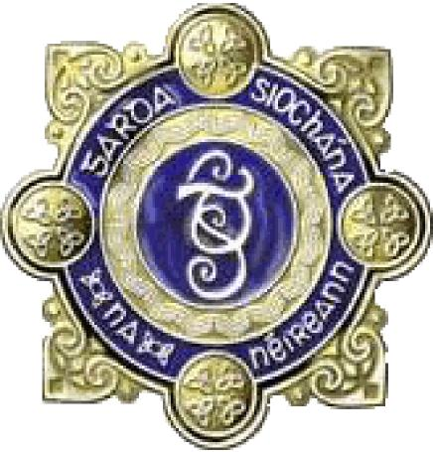

**TRAFFIC PLAN**

**FOR**

**TULLAMORE NATIONAL LIVESTOCK**

**SHOW**

**SUNDAY 10th August 2025**

**Traffic Management:**

The management of traffic is the primary role of An Garda Sìochàna in relation to this event. There are four large car parks amounting to 240 acres selected to accommodate visitors. The four car parks and their selected entrances are strategically located. Dedicated routes have been selected leading directly to the car parks as follows:

1. **North/North East – Tullamore – Site (Green Car Park)**
2. **West/North West – Athlone – Clara – Rahan – Site (Yellow Car Park)**
3. **South/South West – Birr – Blueball – Site (Red Car Park)**
4. **East/South East – Portlaoise – Killeigh – Site (Blue Car Park)**

Alternative Routes have also been selected around Tullamore for traffic not attending the event in order that they can avoid delays. Those alternative routes will be communicated to the public via the media and internet in the days leading up to the event.

***Patrons attending the show are asked to disregard Sat-Nav/Google Maps and to follow the Road Signs for Show Parking.***

**Traffic Plan:**

The Car Parks are located as follows:

**(1)**

**Tullamore Car Park (Green)** has approximately 100 acres of parking and will accommodate all traffic from the North and North East.

Traffic approaching from Kilbeggan, Edenderry and Portarlington will follow the Tullamore By-Pass and take the N52 to this car park. A contra flow system will operate from Mucklagh to the Car park entrance both in the morning and in the evening. The N52 from Tullamore to Blueball will be closed to passing traffic from 7am to 9pm in order to accommodate the event.

**(2)**

**Athlone Car Park (Yellow)** has an approximate size of 30 acres and will cater for traffic approaching the event from the West and North West. Traffic approaching from Athlone will be diverting off the motorway via Tubber, Clara, Coolnahiley, Rahan and into this car park.

**(3)**

**Birr Car Park (Red)** has an approximate area of 52 acres and will cater for traffic approaching the Event from the South and South West. In addition an extra 50 acres of car parking space is available in an adjoining field.

All show traffic approaching from the Birr direction will turn left at Blueball via the Colegap Junction and into the car park. A contra flow system will operate between the Colegap Junction and the car park entrance as required to accommodate traffic approaching from the Cloghan direction along B.357

**(4)**

**Portlaoise Car Park (Blue)** has an approximate area of 48 acres and will cater for traffic from the East and South East. All traffic approaching from Portlaoise on the N80 will be diverted at Killeigh and will approach the Car park via Killurin Cross, Blacklion, Clonterlough and Holmshill. In addition an area of this car park directly off the N.52 will act as a Bus Park accommodating buses bringing patrons to the event. Patrons from this car park will cross the closed section of the N.52 to gain access to and from the Event Site. One Garda and 6 Civil Defence personnel will be on duty at this location to manage the road crossing.

**(5)**

**Disabled Car Park** –

A disabled car park is provided on the event site by organisers. Show committee will issue **PWD Passes** to patrons who wish to use this parking facility. All vehicles displaying PWD Pass will be directed onto the event site.

All persons wishing to avail of Disabled parking and issued with relevant PWD Pass should follow signage for “Livestock Entrance” on the Greatwood Road (**Zone A – BLUE Pass) and enter @ Gate 3.**

Each car park will be operated by stewards selected by the Show Committee. An Garda Sìochàna will have an opportunity to brief the car park stewards before the event.

**(6)**

**Exhibitors**

All **Exhibitors/Competitors/Trade Parking (ZONE B – Pink Pass)** with the exception of livestock will be directed to the main entrance of the site where they will gain access at Gates 5/6.

**Livestock Exhibitors/Competitors/Trade (ZONE A – BLUE PASS)** only will between 7.30am and 9.30am gain access at Gates 2/3 to the site via the closed section of the N52 onto Greatwood Road. In the evening only cattle exhibitors will leave via the closed section of the N52.

**Road Closures:**

The N.52 Route will be closed to through traffic from Mucklagh Junction to Blueball to accommodate the event. Special arrangements will be put in place for anyone residing on that stretch of roadway and for the single business premises located on it. Suitable diversions will be put in place for non-show traffic using this route.

**Parking Restrictions:**

Parking restrictions will apply in the environs of the event particularly:

1. From Mucklagh to Blueball
2. From Blacklion to Portlaoise Car Park
3. From Blueball to the Event Site
4. From Screegan via Glaskill and Agall to the event site (The emergency route).

Local people will be advised of the Road Closures and Parking restrictions. Householders directly affected by road closures will receive written notification of traffic arrangements.

Forwarded, for your information and onwards transmission, please.

John Doran Sgt.

( JOHN DORAN ) 25737M